Scenario: Launch Automation_Practice_Url
Step: Launch "Automation_Practice_Url" WebPage - PASS
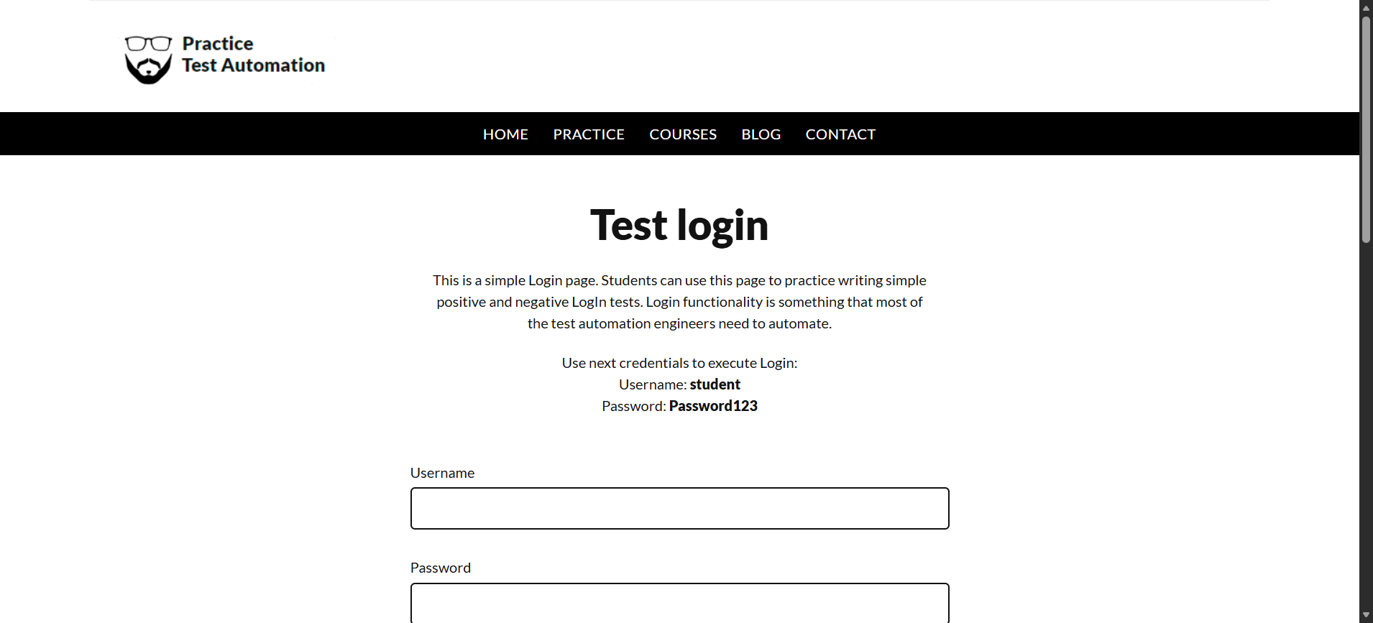
Step: Enter UserName "username" into "Username" textbox at "LoginPage" page - PASS
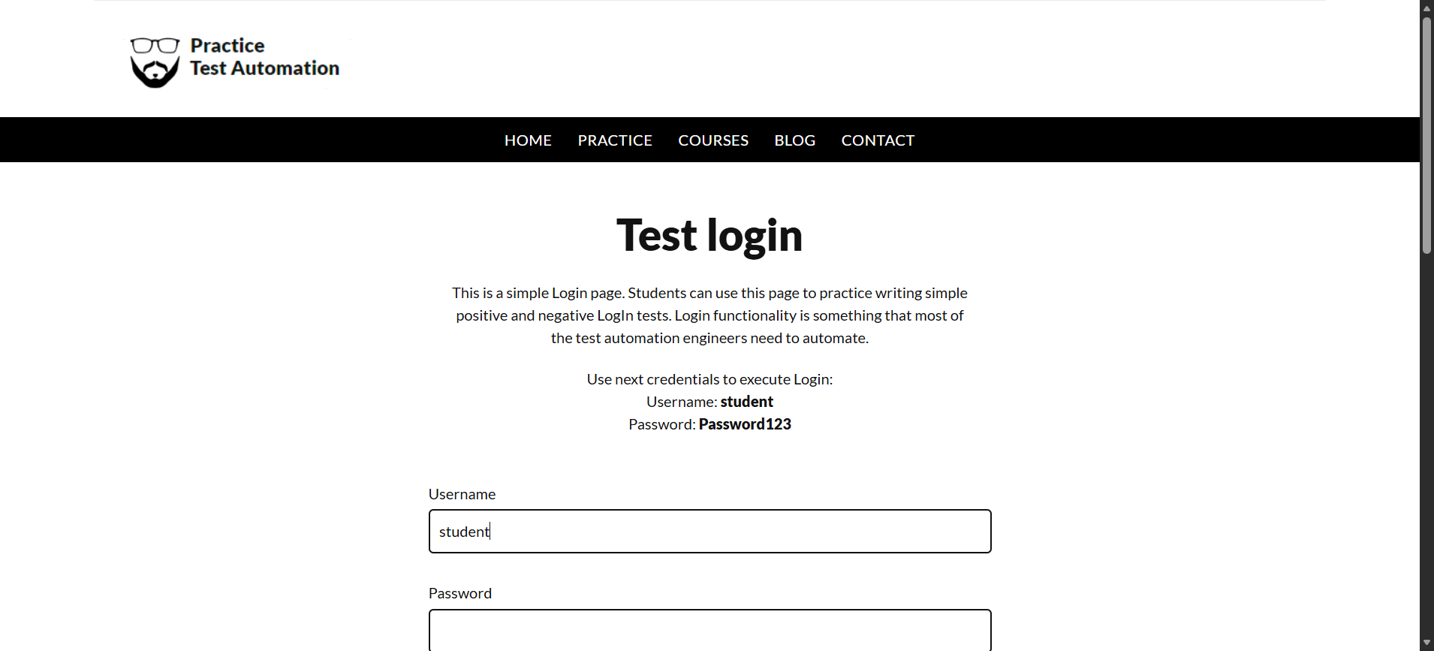
Step: Enter Password "password" into "Password" textbox at "LoginPage" page - PASS
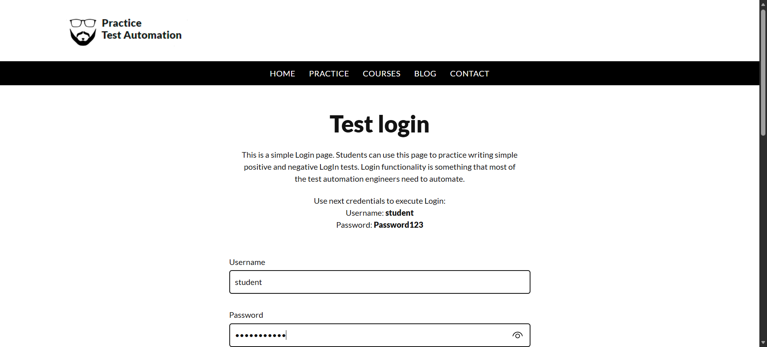
Step: And the user waits for the "login_button" element to be "CLICKABLE" on the"LoginPage"page - PASS
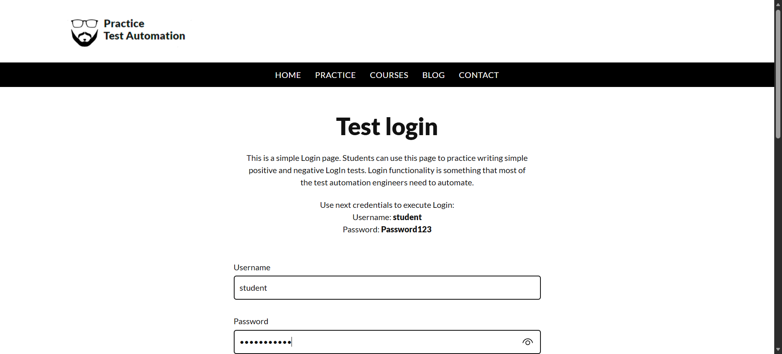
Step: User click the "login_button" element at "LoginPage" page - PASS
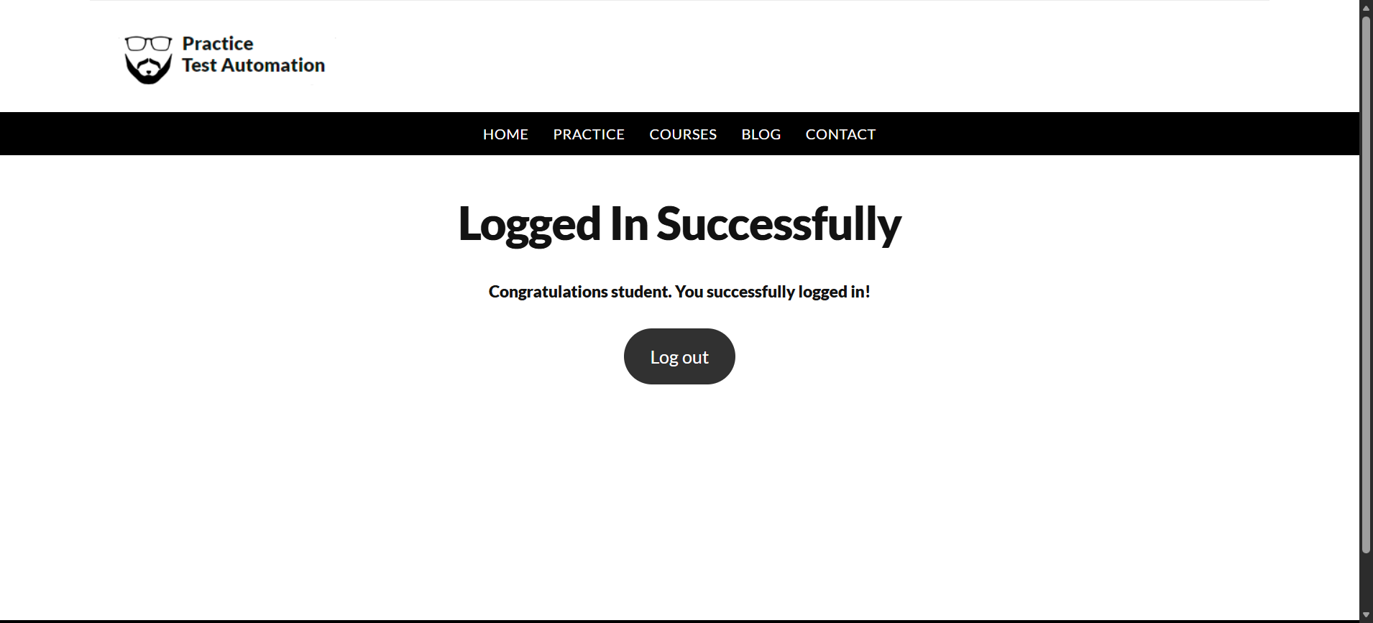
Execution Summary:
Total Steps: 5
Passed: 5
Failed: 0
Scenario: Launch Automation_Practice_Url123
Step: Launch "rahulshettyacademy" WebPage - PASS
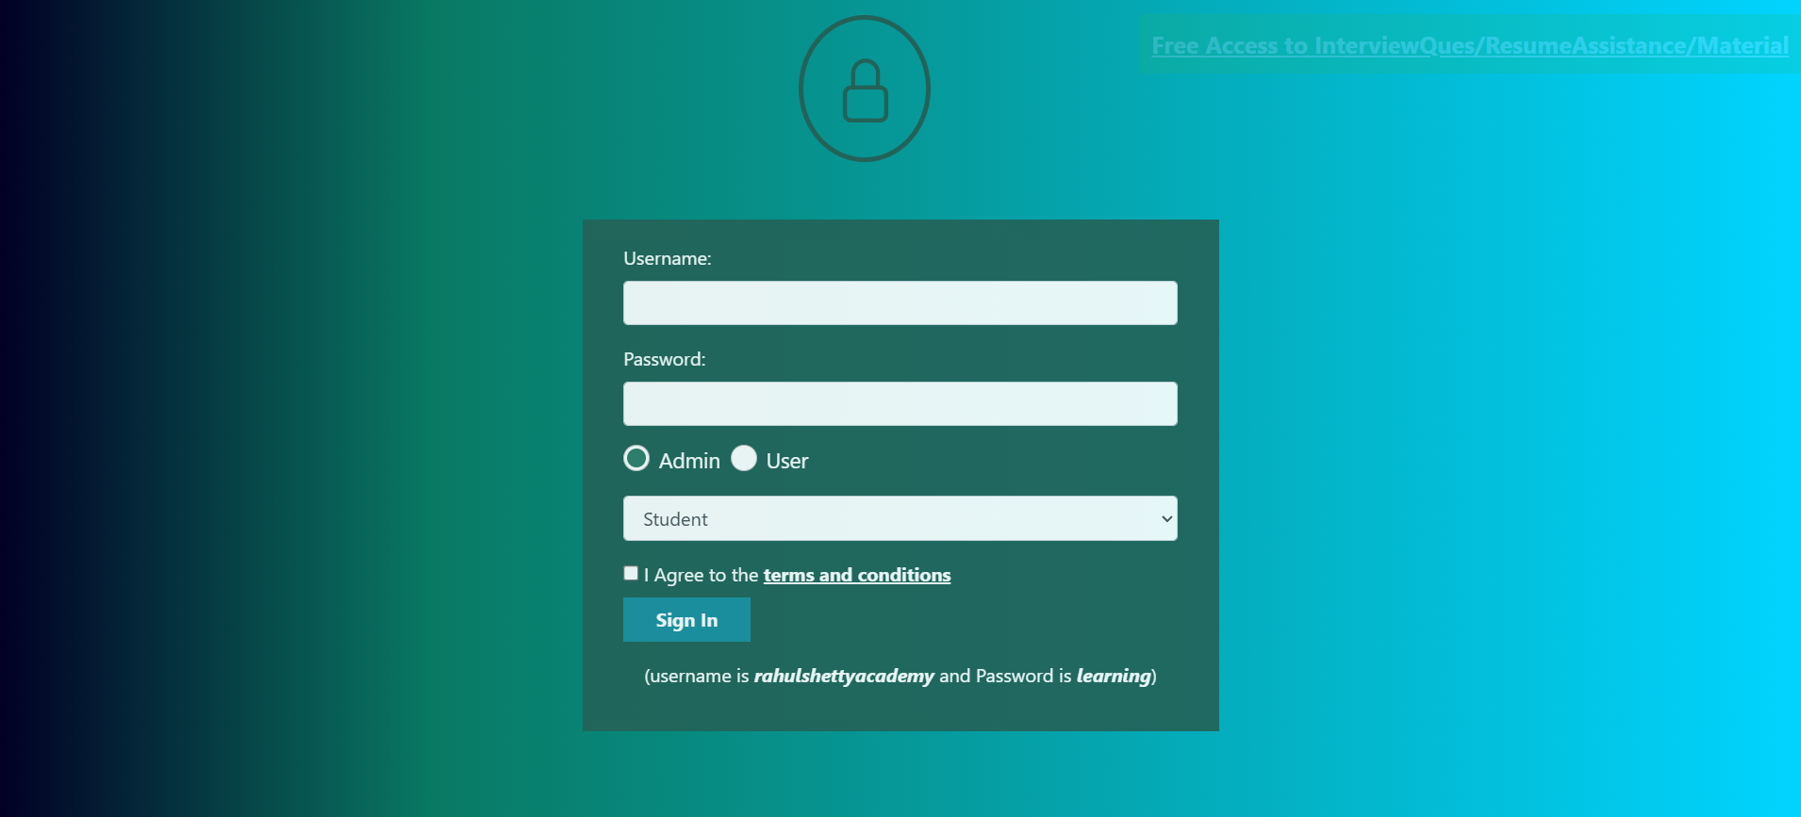
Step: Enter UserName "rahul_username" into "r_username" textbox at "LoginPage" page - PASS
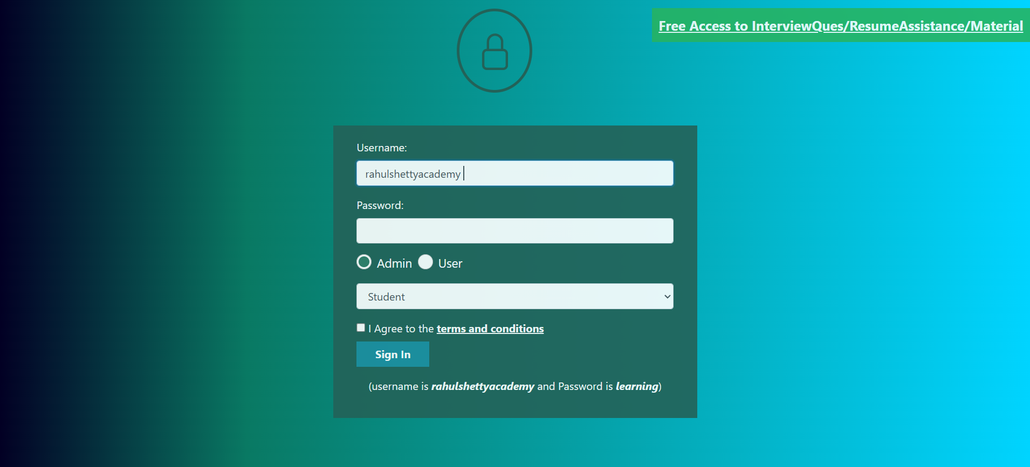
Step: Enter Password "rahul_pass" into "r_password" textbox at "LoginPage" page - PASS
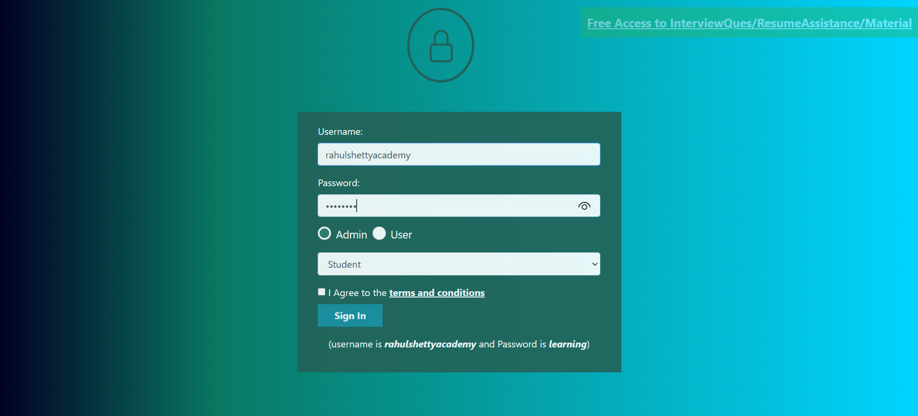
Step: And the user waits for the "r_sigin" element to be "VISIBLE" on the"LoginPage"page - PASS
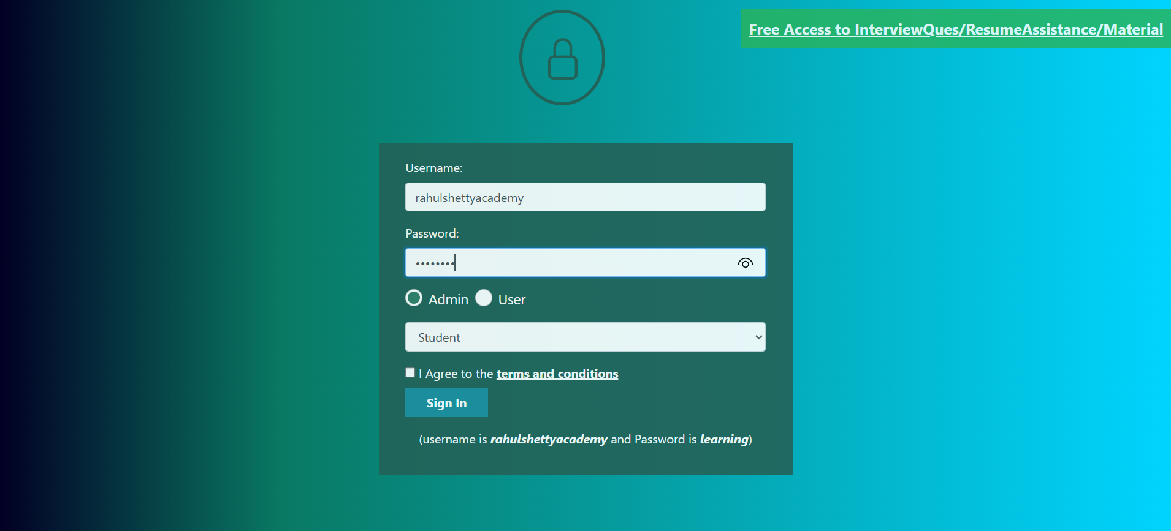
Step: User click the "r_sigin" element at "LoginPage" page - PASS
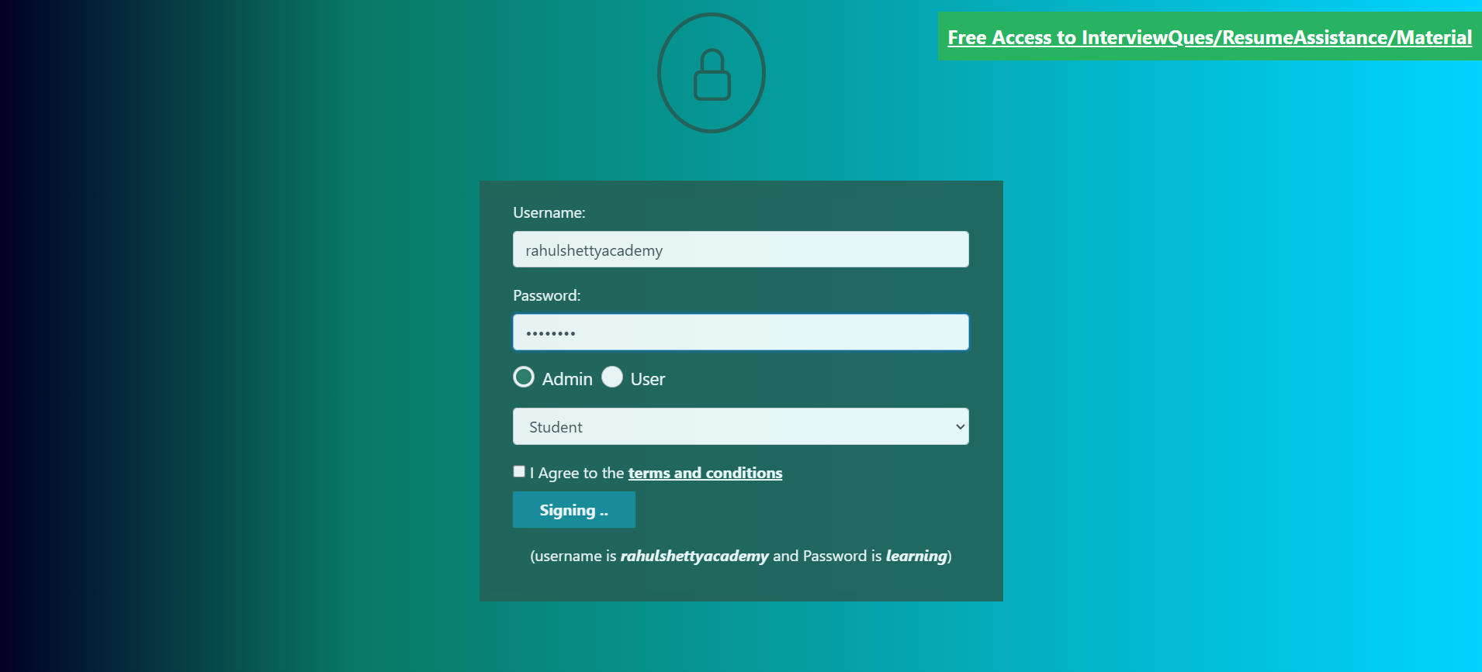
Execution Summary:
Total Steps: 10
Passed: 10
Failed: 0

